APUSH Talking Points
3.1 The Critical Period Transition
AP Focus/Theme  The American Revolution was not a radical transformation like the French or Russian revolutions, but it did produce political innovations and some social change in the direction of greater equality and democracy. | American Pageant:  Chapter #9 The Confederation and the Constitution, 1776-1790  Podcasts: A Brilliant Solution
In post Revolution America, laborers in New York and Boston form political associations to keep lawyers and men of learning and wealthy men form being allowed “swallow up us little folks”  The number of men in the Legislatures of NH, NY and NJ who were ONLY middle class increased from 17% to 60% after the revolution  Even the notion of LIBERTY itself was being redefined:  To the old revolutionary generation liberty meant communities had the right to govern themselves  The people who the revolution cast up in the position of power in America defined liberty more broadly… for them liberty meant access for everyone to the political process and many even a restraint on individual wealth and property to ensure economic equality  By 1785 many of the old revolutionary leadership were dead or had followed the logic of their own positions and turned their political energies back to politics in their own states  Springing up around and beside these old revolutionaries was the leading edge of a new generation which remembered little or nothing of the Stamp Act or the French and Indian War. This was a generation born in the mid 1750’s or the early 1760’s and for them the great formative experience of the lives was not Committees of Correspondence or the Boston Tea Party, but the Revolutionary War itself and service in the Continental Army  These men that had done the actual fighting, the Nation is what they had fought for!!! They carried out of the Revolution an entirely different perspective of what the United States should be.  These teenagers and young adults from NY, Massachusetts and Virginia they had shared so many common hardships that their varied local identities faded away  They had fought and bled under one national flag whose 13 stars and stripes proclaimed UNION, not division. They marched under the orders of one man George Washington (who they had come to adore)  This generation had learned to think continentally  CASE STUDY: Alexander Hamilton (1755 to 1804)  Looked at the jealousy and competition of the individual states as a betrayal of the nation he had fought for. He saw the state legislatures as little better that tiny red necked oligarchies bent on stymieing progress and freezing economic growth.  Chapter #9 guided reading question #6  The Articles of Confederation: America’s First Constitution  What weaknesses plagued the Articles? What was good about it?  Sooner or later State governments which had hobbled congress and destabilized the confederation were bound to do hurt people bad enough to make them wish for a change and by the middle of the 1780’s that time had arrived WHY?  #1 Most of the state constitutions that had been written in the heat of the Revolution had created state governments with a single legislature (broadly and popularly elected)  #2 These state constitutions created a weakened role for Governors and Judges (elected, not appointed)  Consequence: This satisfied the Revolutionary leaders who wanted the popular majority to lead without obstacle and represent the will of the people…but popularity majorities are not always wise majorities. Timid governors and judges are ineffective  1780 Massachusetts writes a new constitution that divides the state legislature into two houses: one elected by the people and one elected by districts (based on property tax). Each house reviews the others legislation.  1784 New Hampshire writes a new constitution which took the appointment process for judges out of the hands of the legislature and gave it to the Governor  1780’s Virginia proposes a new state constitution that gives a veto power in the legislature to the senate and created an independent, lifetime judiciary  Experience was yielding a new prudence (exercising sound judgment in practical affairs)  Reform at the state level highlight the need for reform of the Confederation as a whole1  1785 Virginia and Maryland signed an agreement regulating use of the Potomac river (which the both share as a boundary). This could have been a model for two other commercially vital shared rivers the Susquehanna River and the Delaware River Why wasn’t this agreement used as a model?  Shays’s Rebellion (summer of 1786) adds the added incentive of fear to the invitation to revise the Articles of Confederation.  Chapter #9 guided reading question #9  The Horrid specter of Anarchy  Were the United States of America in danger of falling apart under the Articles of Confederation? Explain  Snapshot of the Convention in Philadelphia  12 states represent (Rhode Island refuses invite)  Total number of delegates 74 sent to attend  Representing the old revolutionary generation  Only 3 had attended the Stamp Act Congress (1765)  Only 8 had signed the Declaration of Independence (1776)  Only a little more that ½ had served in the Continental Congress (1774-81)  Representing the people who the revolution cast up in the position of power in America  22 had served in the Continental Army, 3 under GW  55 of the delegates came from the top 5% of the American wealth pyramid (not the artisans and working men that framed state constitutions).  Many of the men were unknown to the old revolutionaries and unknown to state politics. They were men ready to think continentally  Podcast HW  From Talking History “A Brilliant Solution” | YOUR NOTES:
  Dates | Organization | Attendance
  1781 to 1789 | Articles of Confederation  Power to the states, decentralized gov’t | 13
  1785 | Alexandria Convention  Virginia and Maryland agree to navigation rights on the Potomac | 2
  1786 | Annapolis Convention  Called to discuss problems with the Articles 8 states invited, 5 arrive. Economic problems need to be addressed at the national level (Hamilton) | 5
  1787 | Philadelphia Convention  Called to revise the Article | 12

APUSH Talking Points 4.1
Domestic Policy Under George Washington
AP Focus: As secretary of the treasury, Hamilton has a profound impact on establishing policies that will determine the nation’s economic direction and growth. Deficit spending, initiated in large part by Hamilton, endures as an economic and political tool. (it will be used extensively by FDR in the 1930’s)  2002 AP Free Response question Analyze the impact of the TWO of the following in helping establish a stable government after the adoption of the US Constitution John Adams, Thomas Jefferson, George Washington | American Pageant: Chapter #10 Launching the New Ship of State  Podcasts:
Backstory: After the gov’t was all set up, Washington was elected to be the first President. He was cautious, knowing he was setting precedents for the future [ex. the Cabinet, the State of the Union Address, no big title for President, President not using veto power often].  PRECEDENT #1 GW’s Cabinet : Alexander Hamilton (Treasury), Thomas Jefferson (State), Henry Knox (War), and Edmund Randolph (Attorney General ). These executive department heads were also his chief advisers.  IMPACT: Alexander Hamilton believed the economic stability of the nation was determined by its industrial might. He created a plan to provide a strong monetary system for merchants, creditors, and manufacturers.  HOMEWORK RE-SET  Chapter #10 Customs Duties and Excise Taxes  4. Explain Hamilton's overall economic plan for America.  Bank of the U.S.; Excise Taxes; Funding at Par; Assumption of State Debts; Tariffs  James Madison, objected to the Assumption Bill because it gave the central government too much power and Virginia already paid their debt. He objected to the new securities b/c he felt it was ripping off the original holders. In the end the passage of the Assumption Bill was exchanged in a series of compromises for the location of the capital in the south [on the Potomac].  #1 Report on Public Credit (1790) – Hamilton proposed that Congress assume state debts, combine them w/the national debt, and redistribute the burden of the debt equally throughout the states. He also wanted to issue new government securities covering unpaid interest.  OPPOSITION:  #2 The Bank of the United States – Hamilton submitted another report on recommending the chartering of a national bank that would be capitalized at $10 million and would mainly be funded by private investors. The bank would circulate currency and collect and lend $ to the Treasury. But the big question was – did the Constitution allow the creation of the Bank?  #3 Report on Manufactures (1791) – this last suggestion, which was to encourage American industry through protective tariffs, was rejected.  HOMEWORK RE-SET  Chapter #10 Hamilton Battles Jefferson for a Bank  Know: Bank of the United States, Strict Construction, Loose Construction, Elastic Clause  5. How did the issue of the Bank of the United States reveal a difference in understanding about the Constitution between Jefferson and Hamilton?  HOMEWORK RE-SET  Chapter #10 Mutinous Moonshiners in Pennsylvania  Know: Whiskey Rebellion  6. Was the Whiskey Rebellion a victory for freedom, order, or both? Explain.  HOMEWORK RE-SET FROM CHAPTER #9  The Horrid Specter of Anarchy  9. Were the United States of America in danger of falling apart under the Articles of Confederation? Explain.  Chapter #10 The Emergence of Political Parties  7. Why did political parties develop during George Washington's presidency? Were they good or bad?  FACTION POLTICS vs. PARTY POLITICS  Founding Fathers in 1787 did not envision the existence of political parties because organized opposition seemed disloyal and against spirit of national unity. No national political party had ever existed in America before Washington's administration.  Factions had existed only over special issues - Federalists & Anti-federalists. But factions were not parties. Faction politics tend to be temporary. They are generally local, regional, or special interest oriented. Factional politics usually revolve around the personality of one or two important leaders. A faction forms around one or two issues, and then dissolves with the achievement of one or two political goals.  Political Parties are built around comprehensive, long term formulas for public policy. Parties organize constituencies across the nation and across class or ethnic lines. Political parties offer a more democratic structure for participation – more people can enter the party and it can survive the loss or defeat of one of its leaders.  Jefferson & Madison first organized their opposition to Hamilton only in Congress; did not anticipate creating a permanent, popular party. As their antagonism at Hamilton grew, political parties began to emerge. By 1792-1793, two well-defined groups had crystallized: Hamiltonian Federalists and Jeffersonian Republicans Our two-party system is owed to the clash between Hamilton & Jefferson. | YOUR NOTES:
  HAMILTON said in his Defense of the Constitutionality of the Bank (Feb. 1791): the Congress has all the powers it is not specifically denied so if it doesn’t say you can’t you can! POV of the loose constructionists. | MADISON (also Jefferson and Randolph) said: no way, if the Constitution doesn’t say you can, you can’t. Besides, the elastic clause only allows for necessary bills, and this is NOT necessary. POV of the strict constructionists.
  In the end Washington agreed and the bill was passed and helped the economy. - Set a precedent for enormous federal powers - The elastic clause -- Provided for passing any laws "necessary & proper" to carry out the powers vested in the various governmental agencies.” Also known as Congress’ Implied Powers
  Background | Part of Hamilton’s financial plan was a tax on Whiskey [to pay for assumption] . Southwestern Pennsylvania backcountry folks hard hit by Hamilton's excise tax.
  Reaction(s) | “Whiskey Boys” posed a major challenge to the new national government –They torched buildings, tarred & feathered revenue officers, chased gov’t supporters from the region; some talked of secession from U.S. = Tax collections came to a halt.
  Reaction(s) | Washington summoned the militia of several states resulting in 13,000-man army. Washington accompanied troops part of the way; Hamilton all the way. When the troops reached the hills of w. Penn., the Whiskey Boys dispersed. Washington later pardoned the two convicted participants to heal the rift.
  Significance | Federal government showed it could ensure domestic tranquility  Proved that another Shays’-type rebellion could not succeed under the new Constitution.  Jeffersonians condemned the action as a brutal display of force and gained increasingly more support from ordinary farmers.

THE BIRTH OF THE PARTY SYSTEM
PLEAS NOTE: Be careful not to confuse the Federalists of the 1790s with the Federalists who supported the Constitution in the late 1780s. They are not necessarily the same!! For example, Madison wrote part of the Constitution and Jefferson supported it yet they were not Federalists in the 1790s.
The Federalists in 1787-88 were a faction that supported the Constitution while the Federalists in the 1790s became a political party that embodied Hamilton's financial plan and Washington's presidency.

 | HAMILTONIAN FEDERALISTS | JEFFERSONAIN REPUBLICANS
TYPE of GOVERNMENT | Supported a strong central government to maintain law & order; crush democratic excesses (Shays’ Rebellion)  Federal government should protect life & property of the wealthy. | Democratic-Republicans believed the best government was one that governed least. The bulk of power should be retained by the states. Limit federal authority via strict interpretation of Constitution
WHO SHOULD RULE? | Believed in gov't by upper class (the "best people") The rich had more leisure time to study problems of governing and enjoyed the advantages of intelligence, education, & culture.  John Jay: "Those who own the country ought to govern it." | Advocated the rule of the people; government for the people However, only by those who were literate enough to inform themselves. Believed in the wisdom of the common people; teachability of the masses
ROLE of the COMMON MAN | Distrusted the common people. Regarded democracy as a "mobocracy" and believed democracy too important to be left to the people. | Biggest appeal was to the middle class and the underprivileged -- yeoman farmers, laborers, artisans, and small shopkeepers.
ECONOMY | Federal gov't should encourage business, not interfere with it. The Federalists were dominated by merchants, manufacturers, & shippers Most lived in urban areas of the eastern seaboard where commerce & manufacturing flourished. | Jeffersonians themselves were primarily agrarians and insisted on no special privileges for special classes, esp. manufacturers. They believed Farming was an ennobling profession.
FOREIGN AFFAIRS | The Federalist were Pro-British in foreign policy WHY? Foreign trade with Britain was key in Hamilton's plan. Many Federalists were mild Loyalists | The Jeffersonian Republicans were basically pro-French They supported liberal ideas of the French Revolution. Believed in freedom of speech to expose tyranny.

SOURCE LINKS:
www.historysage.com
www.teach12.com
APUSH Talking Points 4.2
Foreign Policy Under George Washington
AP Focus:  Washington warns the new nation about establishing alliances with foreign nations; the key to America’s future, according to the first president, lies in neutrality  2002 AP Free Response question Analyze the impact of the TWO of the following in helping establish a stable government after the adoption of the US Constitution John Adams, Thomas Jefferson, George Washington | American Pageant: Chapter #10 Launching the New Ship of State, 1789-1800
WASHINGTON’S NEUTRALITY PROCLAMATION (1793)  U.S. still obligated to France under the Franco-American alliance of 1778 and the US had pledged to protect French West Indies from enemies (Jeffersonians favored the Alliance) President Washington believed war should be avoided at all costs WHY? U.S. was militarily weak in 1793 and should stay out of the war. (Hamilton & Jefferson in agreement)  Neutrality Proclamation of 1793 - Proclaimed U.S. neutrality toward the war between Britain and France and warned citizens to be impartial to both Britain & France  Washington's Neutrality Proclamation  Know: Franco-American Alliance, Neutrality Proclamation, Citizen Genet  9. Explain the reasoning for and against Washington's Neutrality Proclamation.  American Reaction - Jeffersonians enraged, especially by Washington not consulting Congress. Federalists supported it.  Citizen Genet - French envoy/ profiteer who tried to entice U.S. profiteers to outfit French ships and supply the French war cause; he recruited Americans in this effort. Genet believed Neutrality Act did not truly reflect American public opinion and suggested bypassing Washington by appealing directly to the voters. Washington demanded his withdrawal & Genet was replaced.  America & France benefited from U.S. neutrality HOW? America's neutrality meant it could still deliver foodstuffs to the West Indies. France did not officially ask the U.S. to honor the Franco-American treaty.  If U.S. entered war, British navy would blockade U.S. coasts and cut off supplies the French relied on.  JAY TREATY (1794)  Background: British continued harassing American frontier settlers and U.S. ships on the oceans. The British remained in their northern frontier posts on U.S. soil (a violation of the Peace treaty of 1783) They also sold firearms and alcohol to Indians who attacked American settlers and their navy seized about 300 U.S. ships in West Indies starting in 1793. Hundreds of Americans impressed into service on British vessels; hundreds of others imprisoned.  Diplomatic Developments: Federalists were unwilling to go to war because the U.S. depended on 75% of its customs duties from British imports. Jeffersonians argued that U.S. should impose an embargo against Britain. Washington sent Jay, the Chief Justice of the Supreme Court, to London in 1794. The Jeffersonians feared the conservative Jay would sell out U.S. interests. Jay feared war with Britain and was willing to appease her.  Treaty Provisions: (America won few concessions) The British renewed their pledge to remove their posts from U.S. soil (as in 1783). They consented to pay damages for recent seizures of American ships. In addition the British refused to guarantee against future maritime seizures and impressments or the inciting of Native Americans to violence on the frontier. The was U.S. forced to pay pre-Revolution debts owed to British merchants  Reactions: The Jay Treaty was so lopsidedly pro-British that the Federalist administration was embarrassed. .Jeffersonian outrage resulted in creation of the Democratic-Republican party. The South felt betrayed that northern merchants would be paid damages. Southern planters would be taxed to pay pre-Revolution debt.  Results: War with Britain was averted . Washington pushed for ratification of the treaty realized war with Britain would be disastrous to the U.S. .The Senate narrowly approved the treaty in 1795.  Jay's Treaty and Washington's Farewell  Know: Jay's Treaty, Farewell Address  11. Did John Jay betray American interests in Jay's Treaty.  PINCKNEY TREATY (1795)  Background: Spanish feared an Anglo-American alliance and sought to appease U.S. Spain was a declining power in Europe and their influence was declining on the American frontier  Treaty provisions: (Spanish concessions) The US was granted free navigation of the Mississippi River to the U.S. including right of deposit at the port city of New Orleans. This yielded large area north of Florida that had been in dispute for over a decade. The 31st parallel recognized as legal border between U.S. and Spanish Florida. Ratified by Senate in 1796.  Washington had reluctantly accepted a second term at the urging of his supporters (Unanimously reelected)  Washington lost his nonpartisan standing when he became a Federalist verbal abuse from Jeffersonian wing was significant  Refused to accept a third term as President setting a precedent for the 2-term presidency Washington exhausted physically and weary of verbal abuse  Content of Farewell Address (1796) Warned against evils of political parties and warned against permanent foreign alliances (like treaty with France) Isolationism became dominant U.S. foreign policy for next 100 years. SUMMARY: S.A.F.E - Stay Away from Foreign Entanglements  REVIEW OF WASHINGTON’s PRECEDENTS  #1 President relied on and consulted regularly with his cabinet  #2 Chief executive gained the right to choose his own cabinet -- This custom grew out of Congress' respect for Washington  #3 Presidential cabinet used to promote domestic programs (Hamilton)  #4 Two-term office for president  #5 After Jay resigned, Washington went outside the Supreme Court to select a new Chief Justice | YOUR NOTES:

APUSH Talking Points 4.3
The Presidency of John Adams
AP Focus:  After Washington’s administration, the Federalists passed legislation that restricted civil and political rights. A response in the form of the Virginia and Kentucky Resolutions offers a states’ rights challenge to questionable federal laws  2002 AP Free Response question Analyze the impact of the TWO of the following in helping establish a stable government after the adoption of the US Constitution John Adams, Thomas Jefferson, George Washington | American Pageant: Chapter #10 Launching the New Ship of State, 1789-1800  Podcast: Talking History “Perilous Times – Free Speech in Wartime”
HOMEWORK-RE-SET  John Adams Becomes President  12. What handicaps did John Adams face as he became president?  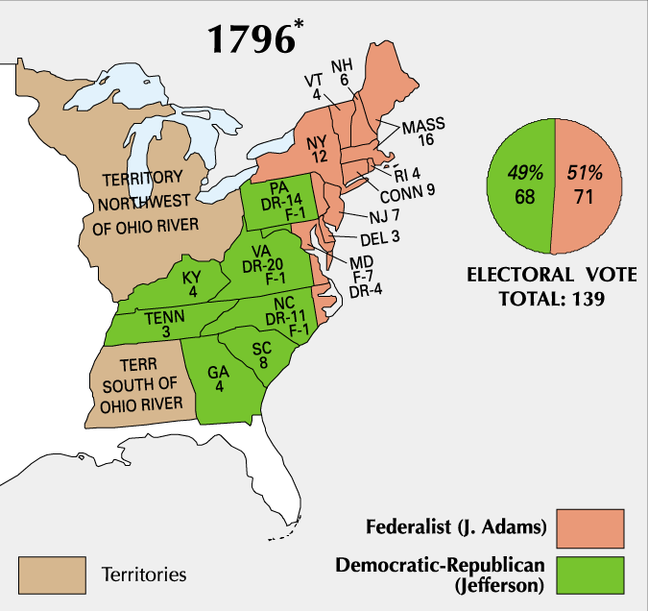  The Constitution in 1796 required presidential electors to place the names of two individuals on their ballots; the candidate with the highest vote count, if a majority, became the president and the runner up the vice president.  The results were not anticipated by anyone. Adams won with 71 electoral votes, but was followed by Thomas Jefferson with 68 votes; Thomas Pinckney trailed the leaders with 59. The president was a Federalist, but the vice president was the leader of the Democratic Republicans opposition – an untidy situation.  Sectionalism (see map above)  Placing the interests of one region over those of the nation as a whole. The Election of 1796 illustrated this > the North voted for Adams; the South voted for Jefferson.  HOMEWORK-RE-SET  Adams Puts Patriotism above Party  14. How did avoiding war with France hurt John Adams' political career?  XYZ Affair (1797) “Millions for defense, but not one cent for tribute”  Requests of bribes in exchange for negotiations by France. French ships were seizing U.S. vessels carrying British goods since the two countries were at war. 1797 President Adams sent a delegation to Paris in 1797 (including John Marshall). The U.S. delegates secretly approached by three French agents- XYZ . They demanded a large loan and a bribe of $250.000 for the privilege of talking to French foreign minister Talleyrand. Negotiations broke down and Marshall came home—seen as a hero War hysteria swept the U.S.  Alien & Sedition Acts  American citizenship requirements raised from 5 –14 years; jail time or fines for anyone expressing opinions damaging to the government; President could deport violators  Foreigners (immigrants, French and British radicals), and members of the Democratic – Republicans  HOMEWORK-RE-SET  The Federalist Witch Hunt  15. Explain the reasons for the passage of the Alien and Sedition Acts.  Nullification  Principle that states had the right to nullify, or consider void, any act of Congress that they deemed unconstitutional. A major factor in the march toward Civil War.  Virginia & Kentucky Resolutions  These states viewed the Alien & Sedition Acts as unconstitutional because they violated the 1st Amendment and deprived citizens of their rights . Showed the balance of power between the states & the federal government remained a controversial issue.  HOMEWORK-RE-SET  The Virginia (Madison) and Kentucky (Jefferson) Resolutions  16. Which was more dangerous to the US Constitution: the Alien and Sedition Acts or the Virginia and Kentucky Resolutions? Explain.  THEMES TO FOLLOW  “History Doesn’t repeat itself, but at least it rhymes”  Alien and Sedition Acts 1798  A series of 4 laws enacted in 1798 to reduce the political power of recent immigrants to the U.S., who tended to favor the anti-British Democratic Republican Party.  RESULTS: Federal government prosecuted and jailed Republican editors, publishers, and politicians  Espionage and Sedition Acts 1917  A person could be fined up to $10,000/20 years in prison if they interfered with the draft, obstructed the sale of bonds, or saying anything profane, disloyal, or abusive about the war effort  RESULTS: 6,000 arrests for loosely defined anti-war activities (1,500 convictions)  House of Reps refused to seat a Socialists Congressman critical of the war Supreme Court hears Schenck v. U.S case in 1917  The Alien Registration Act of 1940 (Smith Act)  The act, which made it an offense to advocate or belong to a group that advocated the violent overthrow of the government.  RESULTS: This was the basis of later prosecutions of members of the Communist and Socialist Workers parties. | YOUR NOTES:

APUSH Talking Points 5.1
Thomas Jefferson’s First Term
AP Focus Jefferson’s election was considered a “revolution” because he represented the common people for the first time. Trying to again avoid war with England or France, Jefferson bumbled around with an embargo. His theory was that the only way to avoid war was to stop interaction between U.S. ships and Europe. The overall effect was to kill U.S. trade and enrage the merchants and businessmen up North. The Louisiana Purchase came as a complete surprise and quickly doubled the size of the U.S.  AP Free Response 2004 (B) To what extent was the election of 1800 aptly named the “Revolution of 1800?” Respond with references to TWO of the following: Economics, Foreign Policy, Judiciary, Politics | American Pageant: Chapter 11: Triumphs and Travails of the Jeffersonian Republic  Podcasts:  Talking History: Louisiana Purchase; Lewis and Clark  Stuff You Missed in History Class: How Thomas Jefferson worked; How did a shipwreck double the size of the US? How the Louisiana Purchase Worked
The Jeffersonian "Revolution of 1800"  2. Was the 1800 election more or less important than the 1796 election? Explain.  Responsibility Breeds Moderation  4. How revolutionary was the "Revolution of 1800?"  The Jeffersonian “Revolution of 1800”  Campaign Issues: Alien and Sedition Acts, Relations with France and England  Federalists – John Adams and Alexander Hamilton were splitting the vote Major issue – relations with France  Republicans – Thomas Jefferson and Aaron Burr. Both ran, Both Thomas Jefferson and Aaron Burr got 73 electoral votes (a tie!!) Adams got 65  Vote went to the House of Representatives (It took 36 ballots to elect Jefferson)  The House was controlled by Federalists and the Federalists wanted to go with Burr because they preferred him to having Jefferson - Alexander Hamilton knew that Thomas Jefferson was the better man and pushed for his election!!  Presidency of Thomas Jefferson  Man with a lot of experience, made James Madison his Sec. Of State, made Albert Gallatin his Sec. Of Treasury  Jefferson’s Goals  #1 Scale back government spending  #2 friendships but no alliances  # 3 strict interpretation of the Constitution  First Job – the spending!!!  Scale down Hamilton’s plan (reduced and eventually eliminated the excise tax) ; got more money from import duties (tariff) and sale of western lands (price reduced to $1.25 an acre; minimum purchase 80 acres; created easy payment plans)  Cut spending HOW? - reduction in military and diplomatic spending  First Big Problem – The “Dead Clutch” of the Judiciary  The "Dead Clutch" of the Judiciary  6 What was the main purpose of John Marshall as Chief Justice? How can this be seen in the  Marbury v. Madison decision?  Facts: Nov 1800 – Adams and the Federalist lost control of the Presidency and Congress as Jefferson and the Democratic-Republicans were to take office in March. In order for the Federalists to keep any control they had to dominate the only remaining branch – the Judiciary. Federalist Congress then passed a new law Judiciary Act of 1801. Reduced the number of Supreme Court Justices.  Created new judgeships – including Justice of the Peace. Some of the last commission were signed at midnight prior to Jefferson’s Inauguration (“Midnight Judges”)  Marbury v. Madison (1803): William Marbury had been one of the “midnight judges” appointed by John Adams in his last hours as president. He had been named justice of peace for D.C., but when Secretary of State James Madison decided to shelve the position, Marbury sued for its delivery. Marshall dismissed the case, but he said that the Judiciary Act of 1789 was unconstitutional, thus suggesting that the Supreme Court could determine the constitutionality of laws (AKA, “judicial review”).  The Next Big Issue – The Louisiana Godsend  The Louisiana Godsend  - Explain two ways that history may have been different if the French had not sold Louisiana to the United States.  TJ asked for $2 million to buy the port - requested money in case we had to go to war over the river and/or the port gave– Robert Livingston and James Monroe – permission to ask France to sell us the port for $2 million  Napoleon  had hopes of regaining control of some land in the western hemisphere fighting against Toussaint L’Ouverture in the West Indies France lost because of a combination of yellow fever and slow reinforcements. The Louisiana Purchase was finalized on April 30, 1803.  Jefferson had a dilemma, since the Constitution said nothing about purchasing foreign land, but on the other hand, this deal was simply too good to pass up!  After considering an amendment, Jefferson finally decided to go through with the deal anyway, even though nothing in the Constitution talked about land purchases. Jefferson had been a strict interpreter of the Constitution, but he was now using a loose interpretation.  Federalists, normally loose interpreters, took a strict interpretation and opposed the purchase. Federalist didn’t want the new lands because they correctly foresaw new lands meant new settlers and new states, which meant more farmers and more Republicans.  Thus, both parties made a full 180° turnaround from their previous philosophical beliefs about the Constitution simply because of the practical matters at hand.  The Senate quickly approved the purchase with Jefferson’s urging, and the Louisiana Purchase doubled the size of the United States. This was the biggest bargain in history averaging 3 cents per acre. The purchase created a precedent of acquisition of foreign territory through purchase.  Louisiana in the Long View  In the spring of 1804, Jefferson sent William Clark and Meriwether Lewis to explore this new territory. Along with a Shoshoni woman named Sacajawea, the two spent 21/2 years exploring the land, 1804-1806 – this land was explored Lewis and Clark + 50 guys got to the Pacific in Dec. 1805  3 major accomplishments of Purchase and exploration  #1 learned about the flora and fauna  #2 made connections with the western Indians  #3 found a pass thru the Rocky Mountains. (1805-1806 – Zebulon Pike explored the Mississippi Valley, Arkansas River and the Rockies)  MAP SKILLS  The Louisiana Purchase - 1803  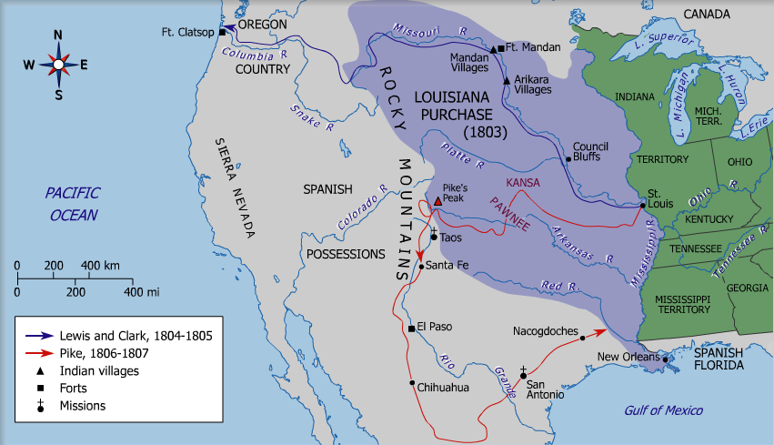  - What consequences did the Louisiana Purchase have on American politics? (Consider struggles between parties, the question over states’ rights, international relations, native American relations, etc.)  - What purposes (other than exploration) did the Lewis and Clark expedition serve?  Summary of Jefferson’s First Term  #1 doubled the size of the country  #2 increased our trade  #3 Eliminated a foreign threat (France) in North America  #4 Reduced debt and domestic taxes  #5 Increased the power of the executive office  All of this was very good – 1804 re-election was no problem - Term #2 wasn’t so good – problems began in Europe | YOUR NOTES:

APUSH Talking Points 5.2
Thomas Jefferson’s Second Term
AP Focus  Despite his intentions, Jefferson, became deeply entangled in foreign policy conflict of the Napoleonic Era, leading to a highly unpopular and failed embargo that revived the moribound Federalist Party  France and Great Britain are at war  Napoleon is getting the upper hand on the land  Great Britain is dominating the seas - Both countries tried to stop the other from getting supplies from other nations – from neutral nations  1805 France made the Berlin-Milan Decree  - closed all European ports to trade with Britain  - French seized any ship going from the continent to Great Britain  1805 Britain responded with the Orders in Council  - restrict trade of neutral countries  - set up a blockade between America and the continent  HW Re-set  America: A Nutcracked Neutral  10. In what way did the struggle between France and Britain affect the United States?  The British began to seize American ships. Because of conditions in the British navy lots of British sailors had left the Navy and come to America to join the American Navy Britain wanted the sailors back IMPRESSMENT (they took Americans too!!)  Chesapeake Affair (1807)  Chesapeake/Leopard Incident- Started when the American ship (Chesapeake) encountered the British ship (Leopard). Chesapeake refused to allow the ship to be searched by the Leopard, so the Leopard opened fire. Chesapeake surrendered and four men were dragged off to be impressed, so Jefferson expelled all British warships from American waters and denounced impressments.  1807 –Jefferson believed that both Great Britain and France needed our trade – he believed that if we stopped trading with them they would see it was wrong to go after neutrals  1807- Embargo Act was passed  no American ship can leave an American port for a foreign port  no foreign vessel can load a cargo at an American port  coastwise shipping must post a bond twice the value of the ship and cargo  once delivery was made the bond would be repaid  Jay’s Treaty (1795) had been ineffective and unpopular – but it hadn’t hurt anyone | American Pageant: American Pageant: Chapter # 11: Triumphs and Travails of the Jeffersonian Republic

HW Re-set  The Hated Embargo  11. Who opposed the embargo and why?  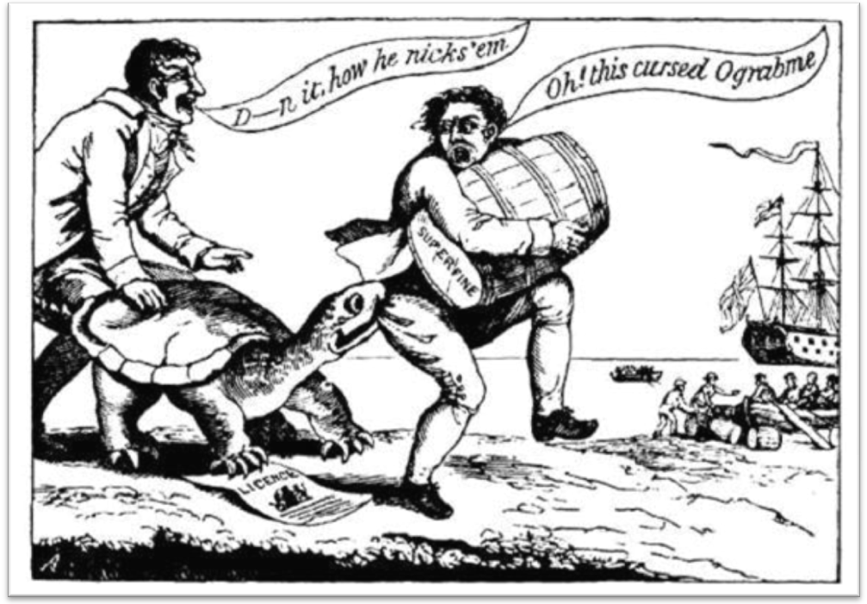  The Embargo Act hurt some…SUCH AS  #1 Merchants in New England (wealthy people in NE)  #2 Shippers and people who ran the ports (who were mostly Federalists)  In New England the states refused to enforce the act there weren’t enough Federal Officials to get the enforcement done they needed help from the states – and they didn’t get it Connecticut – called the act unconstitutional (Sound familiar???) smuggling was going on all over the north east THE ACT WAS A FLOP  1808- Jefferson took his cues from Washington and decided not to run again  1809 – a couple of days before Jefferson left office a new act was passed Non-Intercourse Act  What did it say? We could trade – just not with ports controlled by Britain or France  War between USA and Tripolitania, 1801-05. Tripolitania corresponded to modern northwestern Libya. The Barbary pirates continued to attack US vessels in the Mediterranean Sea, and disagreements as the level of tribute required from the US. The US Navy had been reduced (thanks to TJ reduction in government spending)  A peace treaty is signed, US pays a symbolic ransom of $60,000 and Tripoli frees about 300 US captives | YOUR NOTES:  History doesn’t repeat itself, but at least it rhymes

APUSH Talking Points 5.3
The Presidency of James Madison
Quick Summary of The War of 1812
AP Focus  New Englanders and the Federalist party strongly condemned the War of 1812. The Federalists met to discuss their grievances in Hartford Connecticut in 1814. Many considered discussing secession at a future meeting, which because the war ended never convened.  1808 – Madison beat Charles Pinckney 122 to 47 and took over where Jefferson had left off  Great Britain with the Orders in Council and France with the Berlin and Milan Decrees  Both had established a policy of seizing any neutral ship heading for an enemy port  Not just ships carrying contraband – but all ships  Both the Embargo Act and Non-Intercourse Act had been failures  1810- Madison made another attempt to stop the seizing of ships without going to war  Macon’s Bill #2 (The Highlights) became law on May 1, 1810, was intended to motivate Britain and France to stop seizing American vessels during the Napoleonic Wars. Which ever country (Britain or France) ceased its attacks upon our commerce would be rewarded by having the US stop trading with its enemy  A shift Napoleon jumped at the chance (Even though he continued to harass our guys)  Britain on the other hand stepped up its impressment of sailors furthering the tensions between the US and GB  On the Homefront  There was trouble out west with the Indians and with the new members of Congress who had been elected to represent the new western states  1810- a new group of men – mainly from the west and the south began to gain power and take control of Congress  1811- William Henry Harrison and the Indiana Militia took on Tecumseh (the Indian leader) atTippecanoe and were victorious  The War Hawks and those people out west wanted to blame the Indian uprising on the Canadians  We claimed the Indians got money, supplies and weapons to fight us from the British. Add that to impressment as a reason to be angry with the British  1812 – Neither the US nor Great Britain were itching to go to war with each other – but circumstances took over  - fighting on the frontier with the Indians lead to anger with GB  - constant violations of our neutrality and rights of the sea  - upcoming elections and a very vocal group of western republicans  It’s all going to take us to war!!!!  While the Western Republicans– the War Hawks – were pushing for and getting war – the Federalists were at Hartford, Conn making one last attempt at hanging on | American Pageant: Chapter #12: The Second War for Independence and the Upsurge of Nationalism
  John C Calhoun – SC | They became known as the War Hawks  This group along with the people living in the Northwest Territory were having problems with the Indians
  Felix Grundy – Tenn
  Richard Johnson - Kentucky
  Henry Clay - Kentucky
The Hartford Convention (Dec. 15, 1814 thru Jan. 5, 1815)  Almost from the start the states of New England had refused to co-operate with the war effort  The leadership in Mass. called for a meeting to discuss what they could do  They talked about secession and came up with several resolutions and wanted to see them proposed as amendments to the Constitution:  #1 No embargo shall last more than 60 days  #2 2/3 vote should be required to : declare war, place restrictions on trade, admit new states to the union  #3 no naturalized citizens shall hold public office  #4 taxation and representation based only on the number of free inhabitants  #5 president shall serve only one term  #6 no two consecutive presidents can come from the same state  The resolutions were written up and sent to DC and arrived at the same time as news of the battle of New Orleans and the Treaty of Ghent  They were never acted upon - this was the last straw for the Federalist Party on the national level  The Results of the War We had beaten Britain twice in 40 years ☺  Treaty of Ghent - December 24, 1814 - Ended the War of 1812  Restored the status quo (Everything as it had been before the war )For the most part, territory captured in the war was returned to the original owner. It also set up a commission to determine the disputed Canada/U.S.  We were now seen in Europe’s eyes as a nation  Massive nationalism, great pride and patriotism  End of the Federalist Party – the Republicans were now in complete control | YOUR NOTES:

APUSH Talking Points 5.4
Post War Expansion and economic growth

AP Focus  After the war, the U.S. could focus on herself, as with the “American System” to build up the economy. | American Pageant: Chapter #12: The Second War for Independence and the Upsurge of Nationalism

#1 GEOGRAPHIC GROWTH and WESTERN EXPANSION | 1800-1820 – US population grows from 5.3 million to 9.6 million  1812-1821 – Six new states added to the Union  WHY? lots of cheap land while land prices in the East are steadily rising; Embargo (1807-09) pushed people west looking for $  Transportation revolution (Cumberland Road –1811) and successful victories over Indians led to increased migration west.  By 1820 25% of the population lived in the west | Maintaining sectional balance is the primary goal
#2 HENRY CLAY’s AMERICAN SYSTEM (1824)  BUS, Tariffs and Internal Improvements | Re-charter National Bank (BUS –1816) – to provide national ; extend credit for land purchases and check state banks.  Protective tariffs – promote American manufacturing and raise revenue for transportation infrastructure- Tariff revenues would fund roads and canals and eastern trade would flourish under tariff protection  Internal improvements used to promote growth and commercial agriculture. HOW? Roads and waterways + new and faster vehicles = farmers connecting to new markets!!! | Leads to specialization and interregional dependency (and sectionalism)
#3 TRANSPORTATION REVOLUTION  “Let us bind the republic together with a perfect system of roads and canals. Let us conquer space” | Bonus Bill (1817) John C Calhoun  GOAL: to set aside money (1.5 million to states) made on stock sales from the Bank of the United States for internal improvements. March, 1817 - Madison vetoed the bill because he believed in strict interpretation, and using federal money for internal improvements is not a power granted to the federal government in the Constitution  Erie Canal – 1817  Construction on the Erie Canal financed by the state of New York + private investment finished in 1825.  Steamboats  Robert Fulton – 1810 – improved on Fitch’s boat  ;with the backing of Robert Livingston – they created the first commercial uses for a steamboat

#4 GROWTH OF MANUFACTURING | AFTER THE WAR OF 1812: British Merchants saw the U.S. as a market for their goods. They were willing to sell at well below costs – just to re-establish business in America this hurt American manufacturers who were just starting to get on their feet  these businesses pushed for protection  Calhoun’s Tariff of 1816 The South believed that the development of a home market would help the U.S. economy which would benefit everyone…the protection – especially in the textile industry – led to the beginning of the factory system. This was made possible thanks to two developments:  #1 system of interchangeable parts – Eli Whitney  #2 system of all the work done in one building was developed by Lowell | CASE STUDY: Waltham, Mass. – factory was driven by waterpower. A group – the Boston Manufacturing Company was set up Francis Cabot Lowell hired young, unmarried women just out of high school “factory girls” gave them a place to stay, food, education, recreation  American Industry will get its start
#5 THE SECOND B.U.S (1816)  With the economy expanding – our financial system had to keep up | FIRST BUS: In 1811 – the original charter for the Bank of the United States ended and wasn’t renewed by James Madison and the Republican Congress  PROBLEM The number of state banks then increased, but in most states there was little banking control credit was easily given many people couldn’t pay back loans the financial situation wasn’t good (Sound familiar???)  SOLUTION 1816 – the Second Bank of the United States was chartered. Henry Clay and John C Calhoun had led the move in Congress. | IRONY: The Republicans used the same formulas as First BUS: 4/5 of the $ came from private investment and 1/5 came from the federal government.  National bank was able to get the states back in line, but we still faced financial panic in 1819
#6 THE PANIC of 1819  An economic panic and depression | First financial since at the “Critical Period (1780’s) under the Articles of Confederation – Cyclic panics and depressions will occur every 20 years  CAUSES  #1 Over speculation of frontier lands by Banks (especially BUS)  #2 Inflation from war of 1812 + economic drop-off = vulnerable economy  #3 Deficit trade in balance with Britain  #4 BUS forced wildcat western banks to foreclose on western farms | RESULTS  Western farmers viewed banks as a evil financial monster  Hard hit poor classes looking for more representative government (beginnings of Jacksonian democracy)  Attention drawn to the inhumanity of debtors prisons

APUSH Talking Points 5.5
The Presidency of James Monroe
AP Focus  New Englanders and the Federalist party strongly condemned the War of 1812. The Federalists met to discuss their grievances in Hartford Connecticut in 1814. Many considered discussing secession at a future meeting, which because the war ended never convened. | American Pageant: Chapter #12: The Second War for Independence and the Upsurge of Nationalism
Presidency of James Monroe  The Era of Good Feelings – a time in our history when there was only really one political party the Republicans in power and the Federalists pretty much dead and the Democrats have yet to emerge  Election of 1816 Election of 1820  Foreign Relations – Acquisition of Florida  1817 – Andrew Jackson put in command of a patrol in Georgia that was to guard the border  he did have permission to pursue hostile Indians into Florida if necessary Jackson also let Monroe know that his force could take Florida in 60 days  When Monroe didn’t tell Jackson no – Jackson took it as an OK  Spring 1818 – Jackson went after a group of Indians 175 miles into Florida 2 English traders were killed  In the West Jackson was acclaimed a hero In the Senate and House – he was condemned and they wanted  Monroe to discipline Jackson  Monroe and Adams – John Quincy Adams Sec. Of State – both said NO  1819 – Adams-Onis Treaty  - Florida became part of the United States  - Spain got $5 million  - A more specific line was drawn between Louisiana and Spanish Mexico  Also recognized the U.S. claims in Oregon and Spain stopped claiming land there  Rush –Bagot Treaty 1817  No war ships on the Great Lakes  Set the 49th parallel as the border between Canada and the Louisiana Territory  Foreign Relations – Monroe Doctrine  1810-1824 – Spanish colonies in Latin America had won and/or were winning their independence from Spain  U.S. and Great Britain thought that this was great because these new republics made great trading partners  No Spain was a definite positive  U.S. was also getting a little concerned about the existence of Russia in Alaska  Great Britain asked the U.S. to make a joint statement that opposed intervention of any European country in the Western hemisphere. Also asked to state that neither Great Britain nor the United States would attempt to annex any part of the hemisphere. Monroe asked JQ Adams what he thought Adams said let them make their statement and we can make our own – stand alone  Missouri Compromise, 1820  JQ Adams wrote up the statement – and Monroe issued it in a speech to a joint session of Congress  Known as the Monroe Doctrine US would stay out of Europe  Europe would stay out of Western hemisphere  Doctrine – a big statement from a nation without a military to back it up – we were in no position to stop anyone who wanted to come into our hemisphere  It did show the desire of the US to be taken seriously by the rest of the world  First serious controversy over slavery since the creation of the constitution  1820 – we had 11 free states and 11 slave states  if we admitted Missouri that would upset the balance in favor of the slave states  when Missouri did apply for admission to the union as a slave state an amendment was added to the bill by Representative Tallmadge (NY)  Tallmadge Amendment said  - No more slaves in Missouri  - Any slaves born in Missouri would gain their freedom at age 25  the amendment passed in the House but was defeated in the Senate  Significance – caused a huge political storm  slave states held that Congress had no right to attach conditions upon a state applying for admission  Congress and the free states looked at the Northwest Ordinance as an example of Congress being able to prohibit slavery.  What was really the fight – Slavery ???  NO – the fight was “who had the power?”  It was clearly a states’ rights vs. federal government issue  Compromise was reached – Missouri Compromise  - Missouri would enter the Union as a slave state  - Maine would enter the Union as a free state  - A line would be drawn at 36*30’ – the southern border of Missouri  - Slavery would be allowed below the line and slavery would be prohibited above the line  - The only exception would be the state of Missouri – above the line – but a slave state | YOUR NOTES:
  Federalist pretty much dead on the national level  Republicans go with James Monroe – former Sec. Of State under James Madison  It was an easy victory | Monroe will run basically unopposed  Thus the “Era of Good Feelings”  John Marshall and his rulings continued to be the only Federalist strong hold

